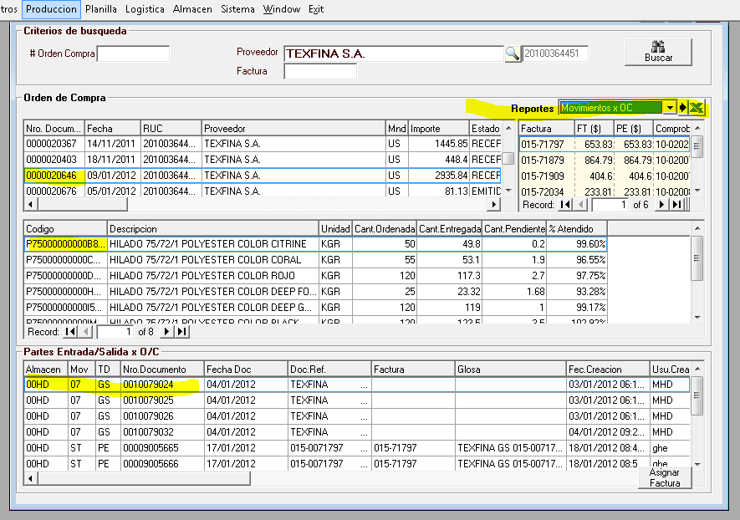

exec RS_OC_S_MOVC_X_OC '0000020646'

EXEC S_RS_OC_S_BuscaOC_Detalle_x_OC_Agrupado '0000020646'

EXEC RS_MOV_S_BuscaMOVD_x_OC '0000020646'

EXEC RS_OC_S_BuscaFT_x_OC_Contralor '0000020646','20100364451 '

